Thank you for taking part in this testing - we appreciate the time taken to complete this and are looking forward to hearing your feedback!

Please feel free to edit this document with feedback on the relevant page!

USER SIGN UP JOURNEY:
As a first step please sign up as a new clinician - to do this visit https://adela734.softr.app/ and click on “Individual”
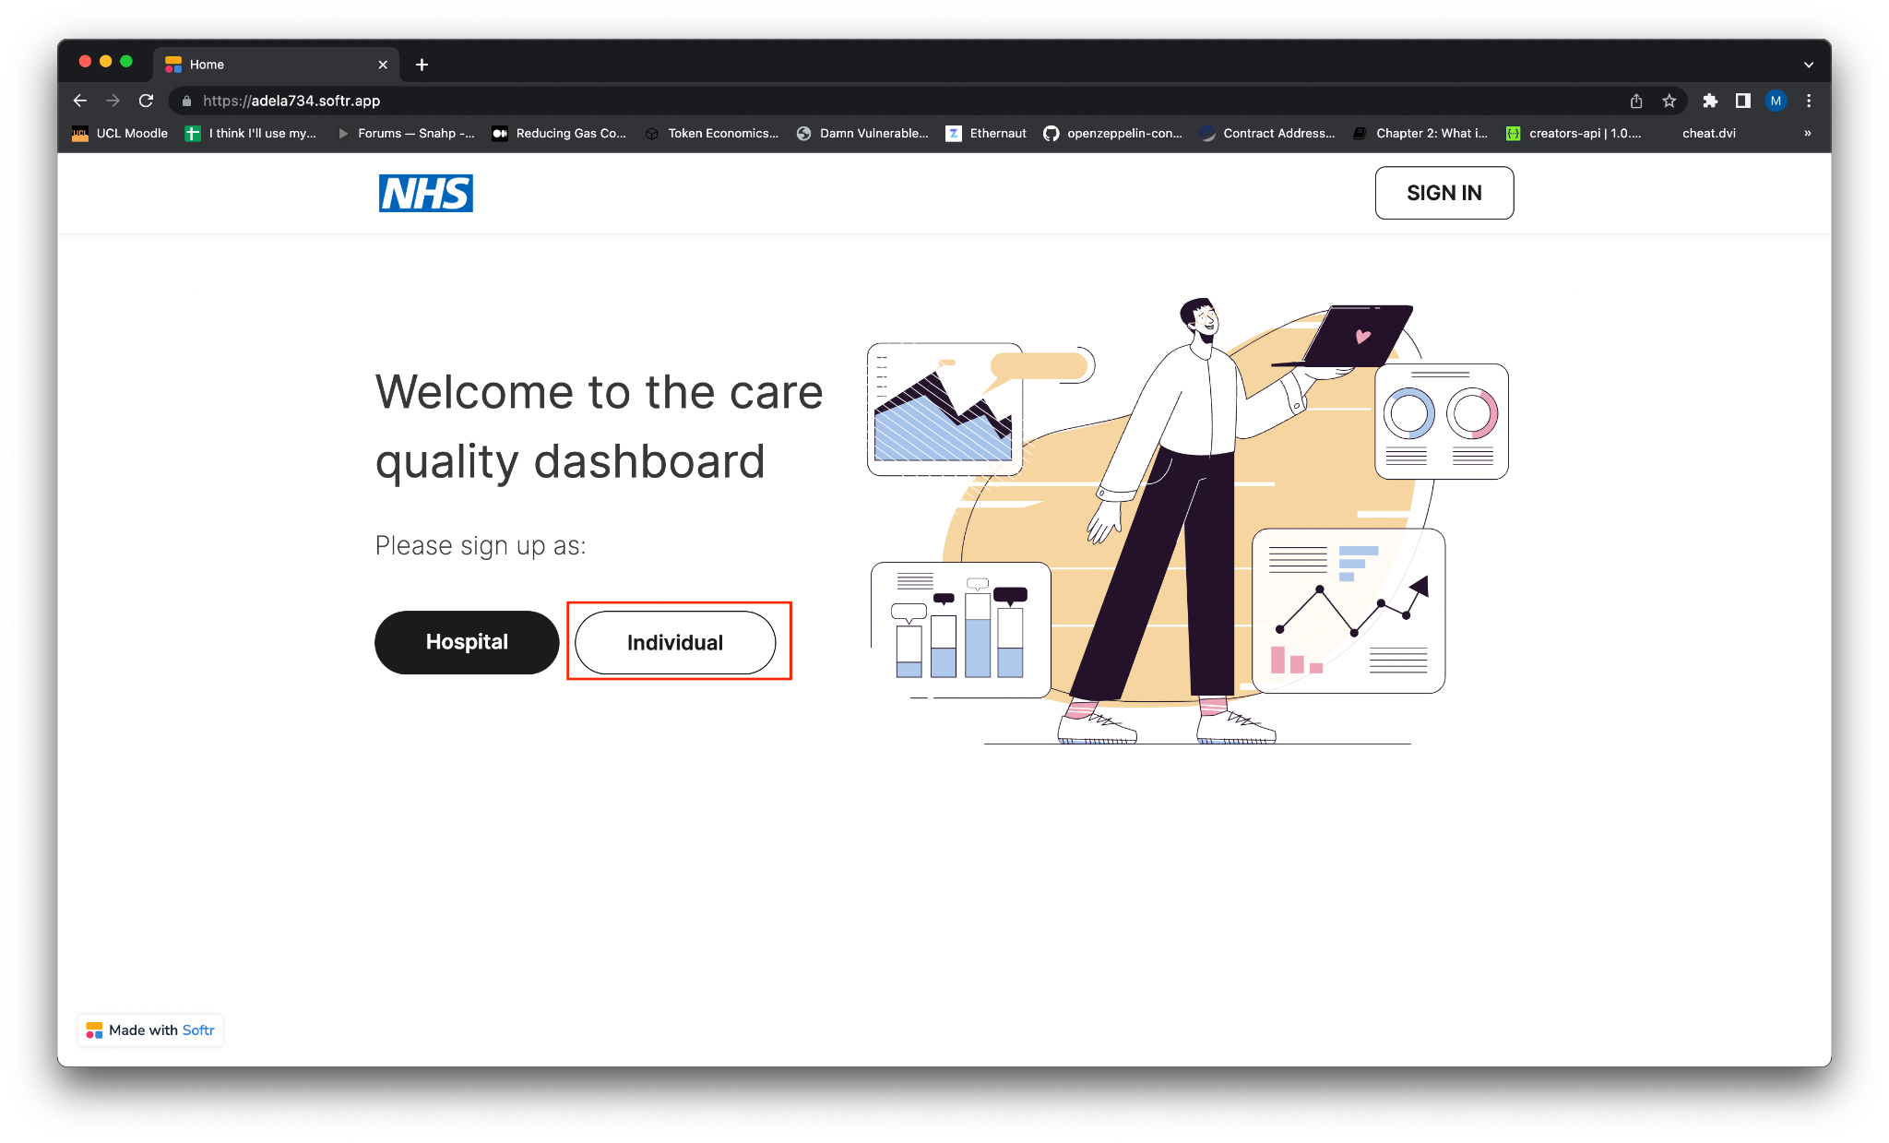

You should be taken to the sign up to the following sign up page:
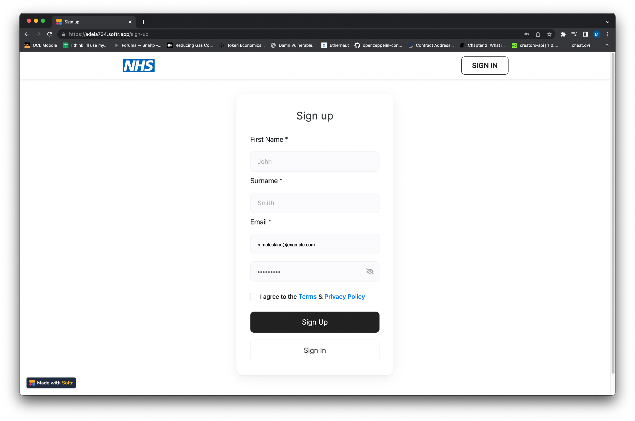
YES/NO

Please sign up by entering your details, once done click “Sign up”. You should be taken to the following page, select “London Central” from the list and click “Confirm selection”.

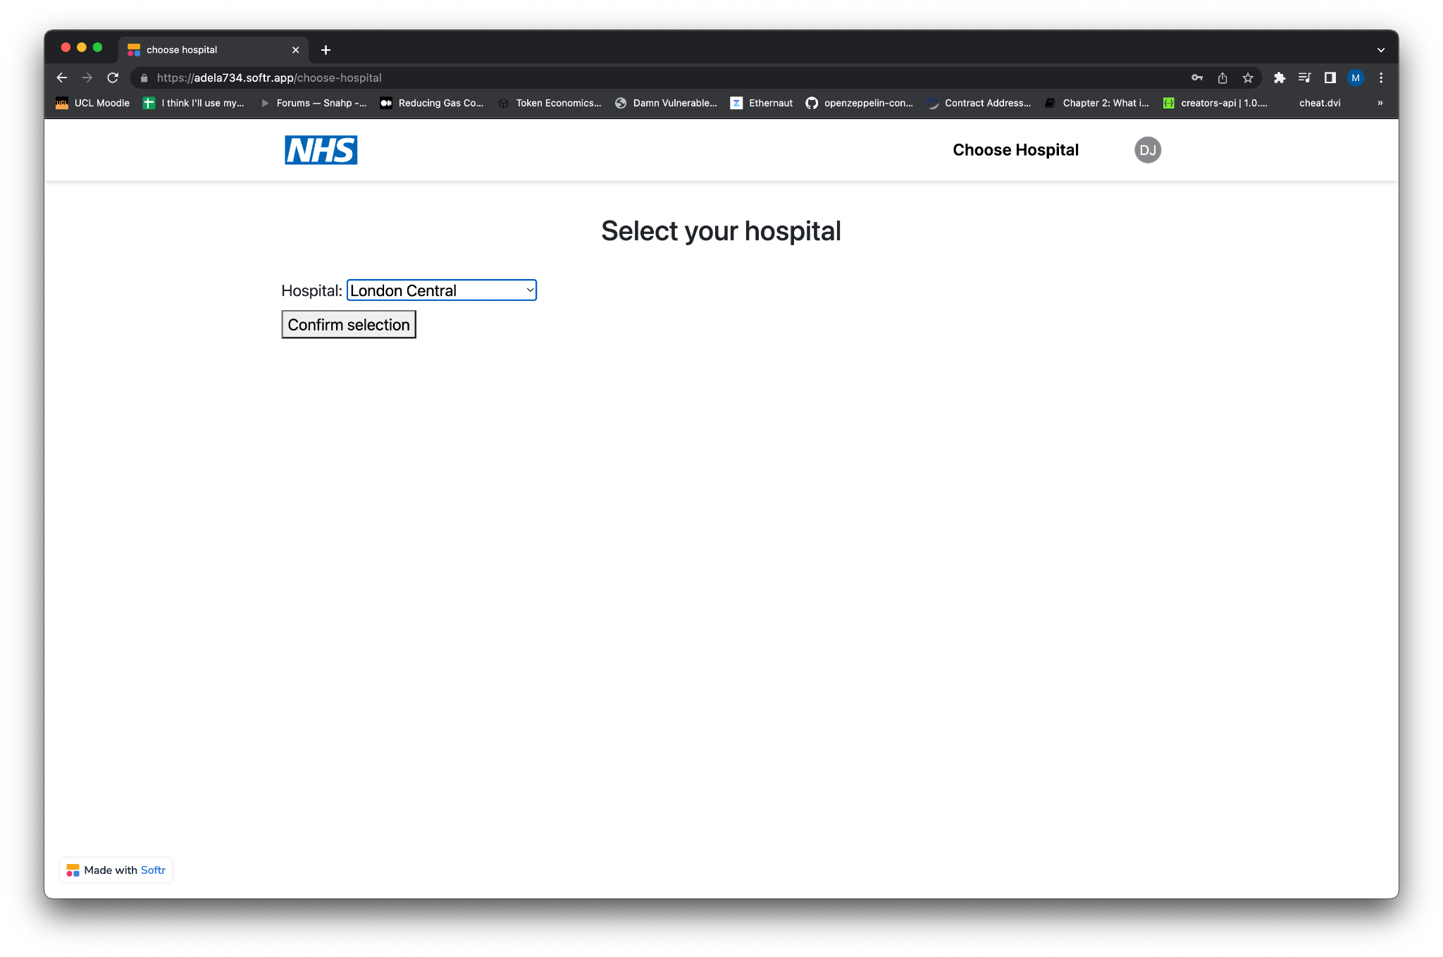
You should now see the following page with the “Your account is pending approval” message below.
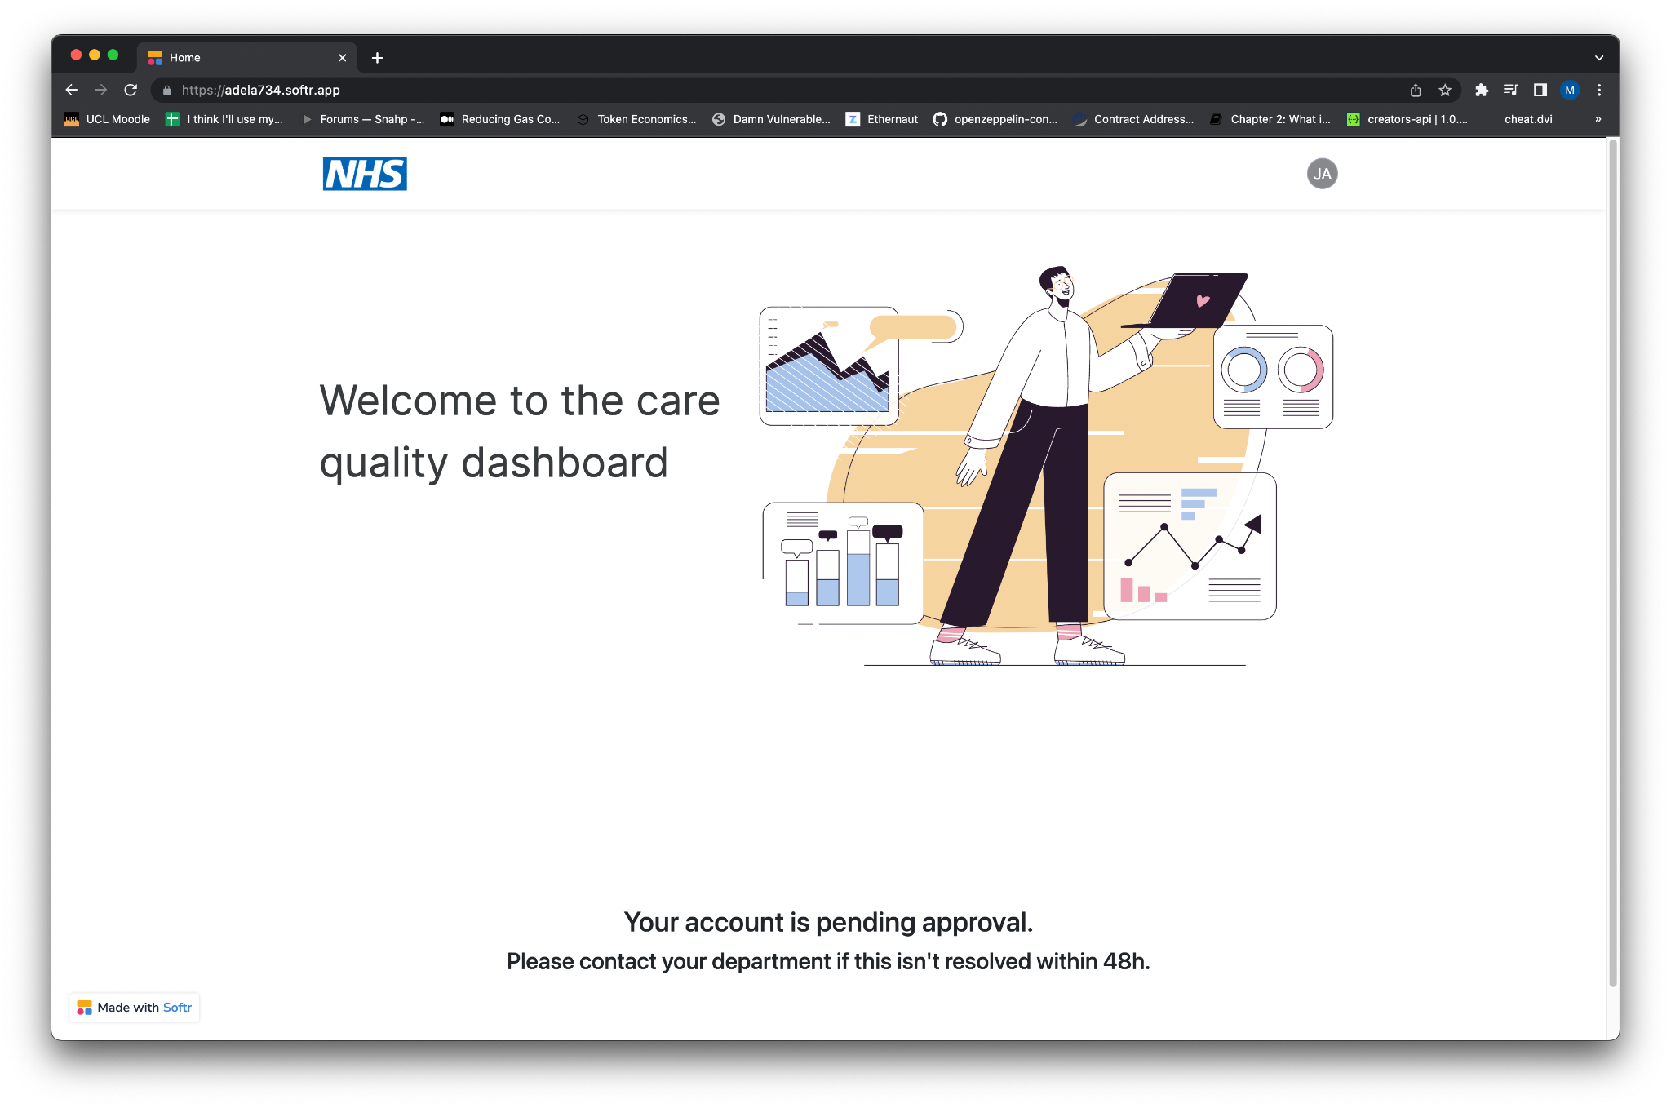
YES/NO

ACCEPTING THE USER
To accept the user, first sign out of the system then log out of the system. Then log in as a hospital head using the following credentials:
Username: mwilliams@example.com
Password: mwilliams123!
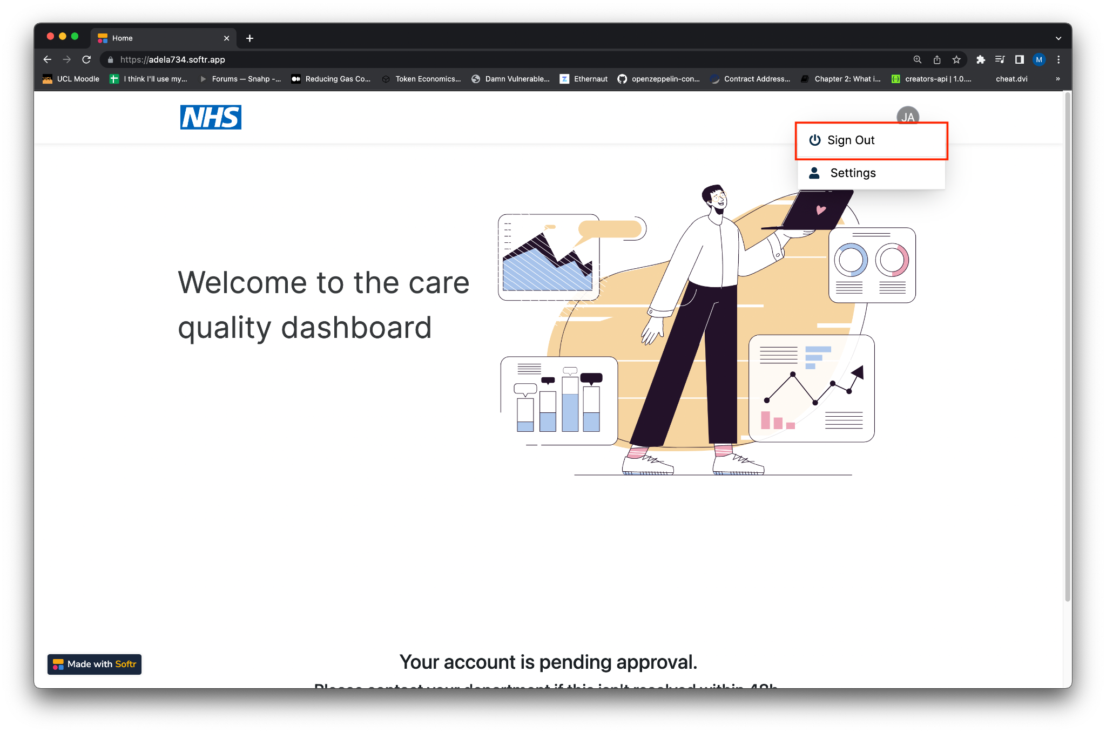
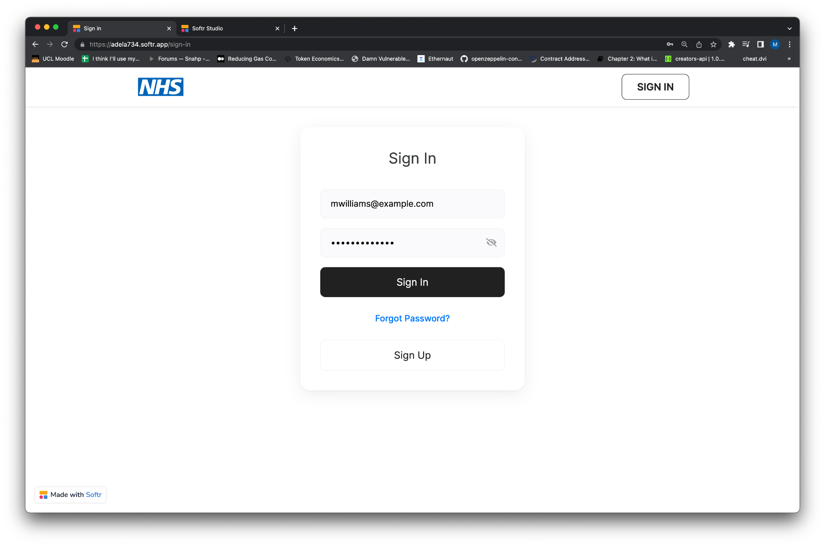
You should now see the user you created as a pending request:
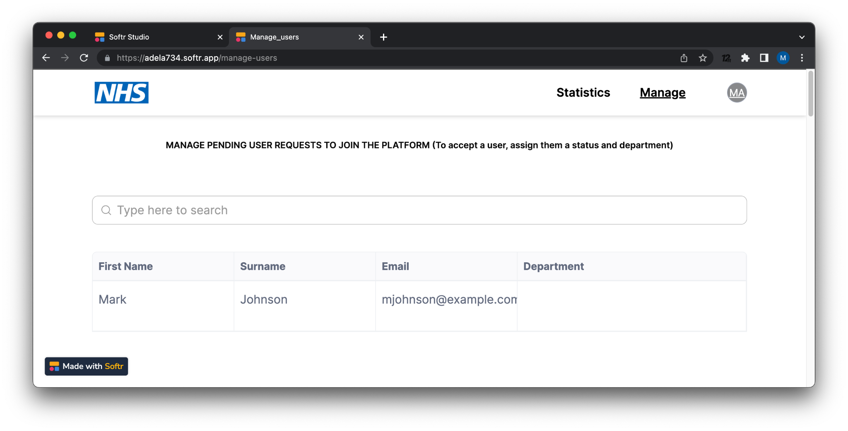
Click on the edit record icon (the pencil), and the ‘Clinician’ status and place them into the ‘Oncology’ department.
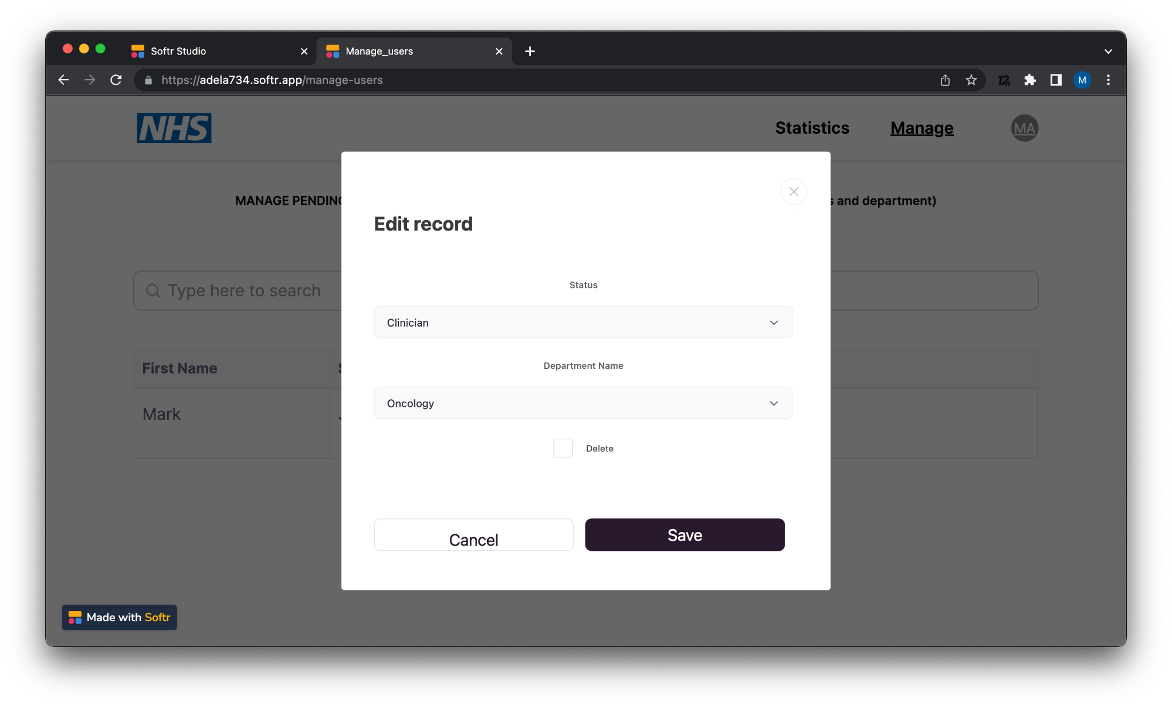
Click “Save”, “Oncology” should now appear on the user’s record.
YES/NO

ADDING A USER TO A FORM
Now let’s add the user to the “Care Quality” form. To do this, scroll down to the “Your forms” section and click on the “Edit” button. Select the newly added user’s email and click “Submit”
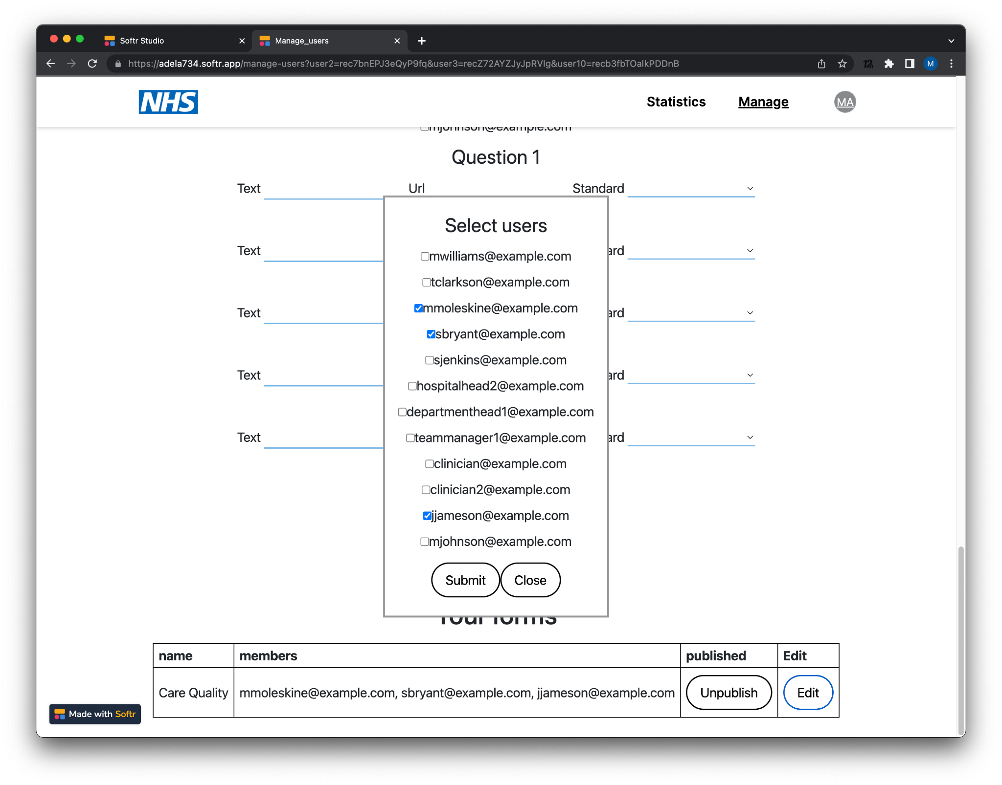
The user’s email should appear on the “members” list
YES/NO

RESPONDING TO A FORM (self-assessment)
Now log in as the newly created user. Upon log in we should be taken to the (empty)
personal statistics page. Go onto the “Self-report” tab, the “Care Quality'' dashboard should be visible.
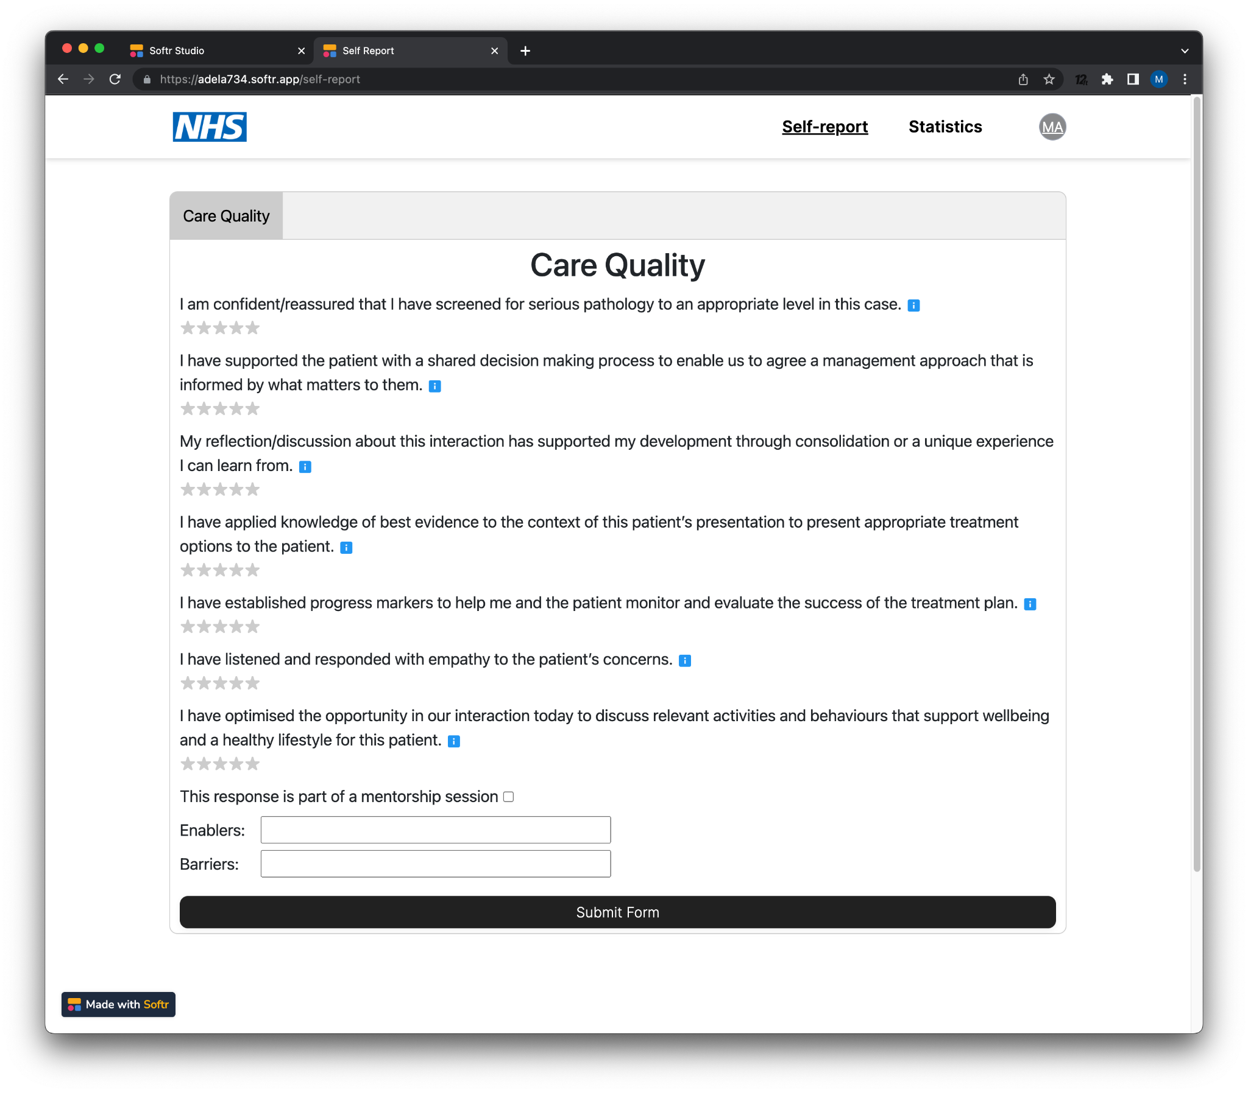
YES/NO
Now go ahead and respond to the form by rating each question, entering a few enablers and barriers and clicking “Submit form”. You should be redirected to the “Statistics page where your entry should be visible”.
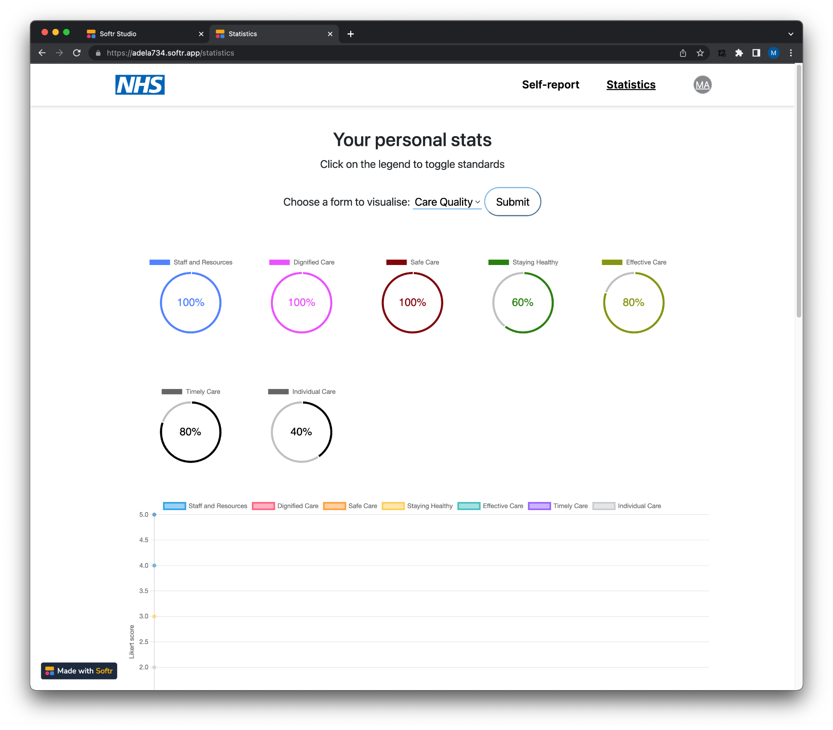
Note: because there is only one response we won’t see any lines in the graph, go ahead and enter another response in the “Self-report” tab, you should now see data for both entries YES/NO

CREATING A TEAM
Now go ahead and create a new team within the “Oncology” department, to do this:
- Log in as the Oncology department head, using the following credentials:
  - Email: tclarkson@example.com
  - Password: tclarkson123!
- You should have been taken to the “Statistics” page, go to the “Manage” page

- Under the “Manage teams” tab, click “Add team”, this should create a new blank team 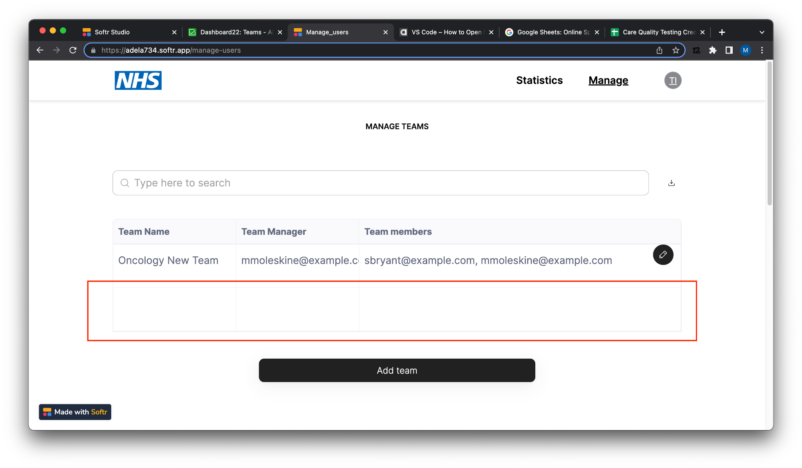
YES/NO
- Edit the record (by hovering over it and clicking the pencil icon)
- Give the team a name, assign the user you created as the team manager and add “sbryant@example.com” as a team member
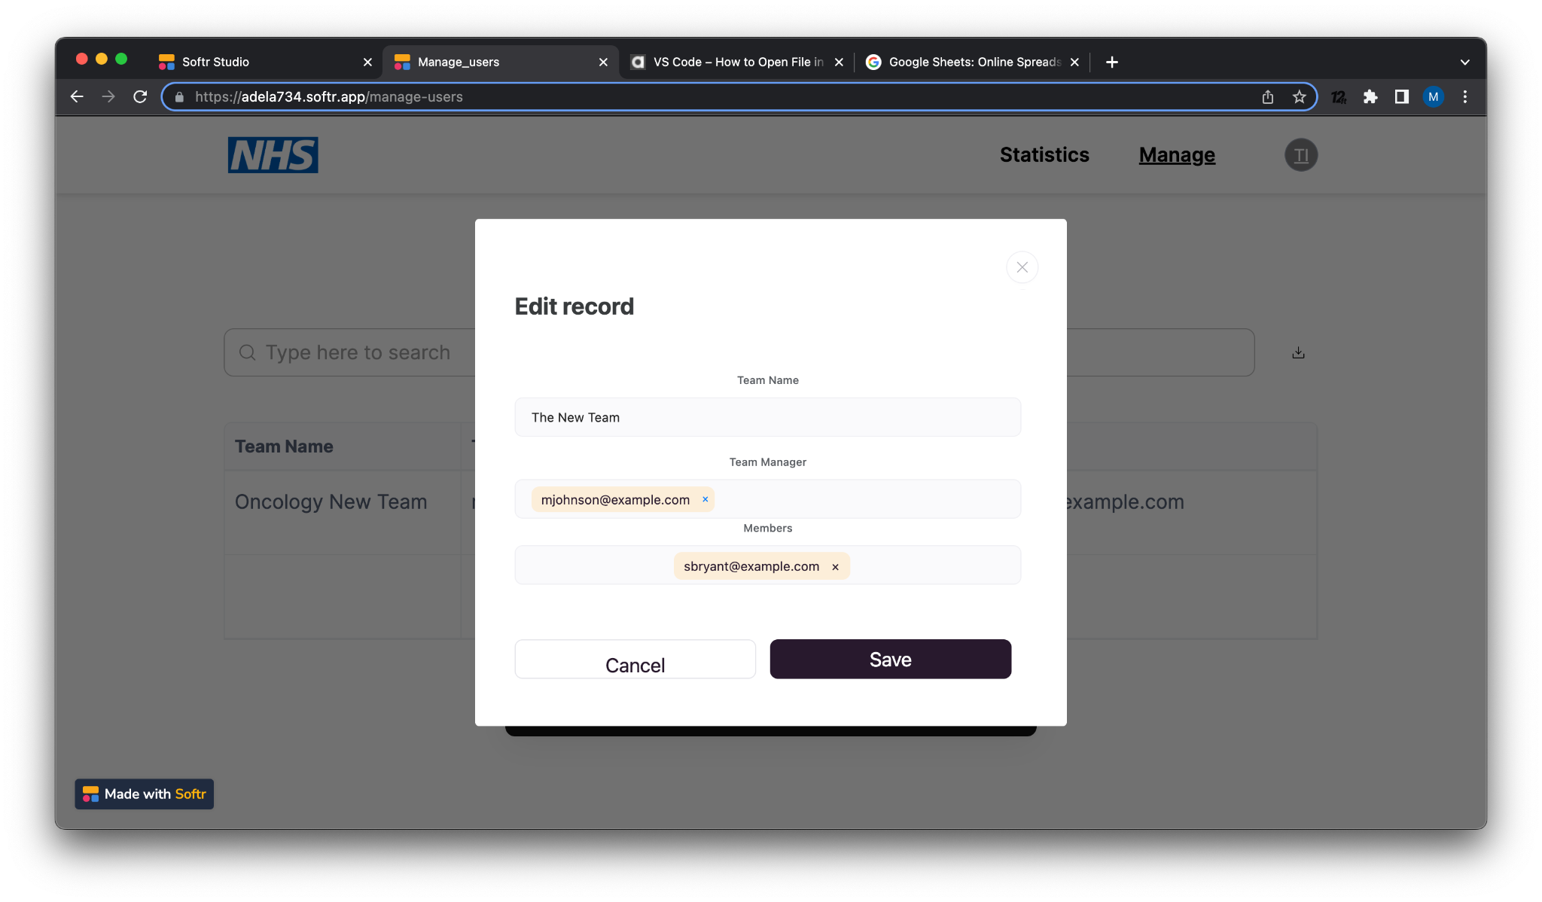
The user you created is now a team manager
Log in as the user you created, you will be taken to the “Statistics” page, scroll down, a page called “Your team’s stats” should now be visible, containing the “Care quality” form, this should contain some datapoints from the user you created and sbryant (the other team member)

YES/NO
CREATING A NEW FORM
Go to the “Manage” tab and create a new form:
- Give the form a name
- Select sbryant and the user you created (these are the users within your team you wish to publish the form to)
- Add text, a guidance url and a matching standard to 5 questions
This is an example form:
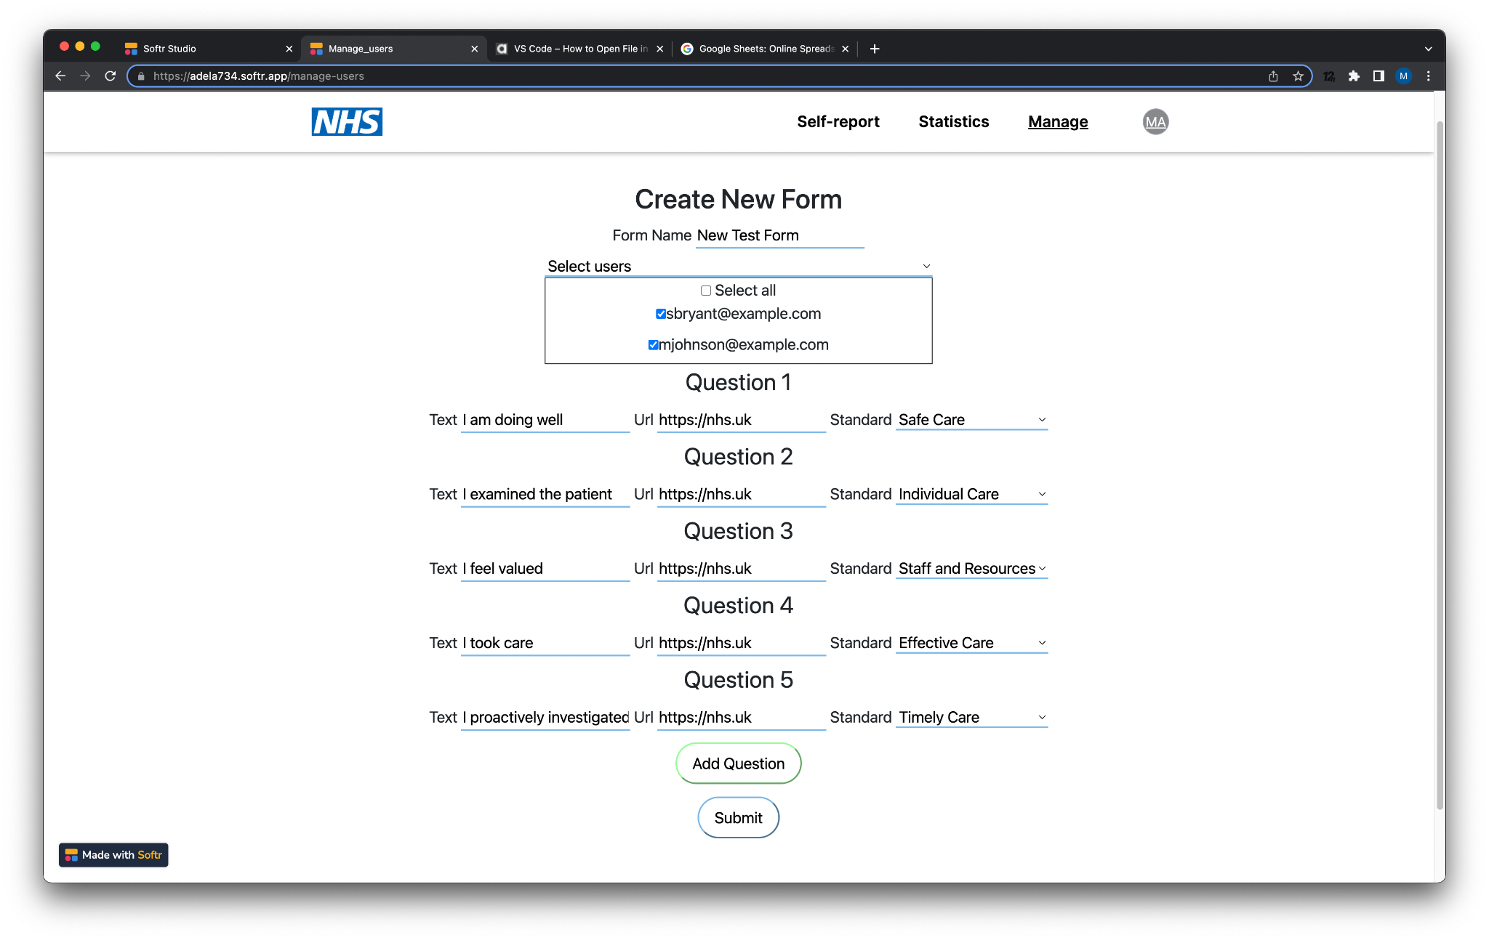
Once completed, click “Submit”. The form should be visible in the self report tab, click it and you should be taken to it.
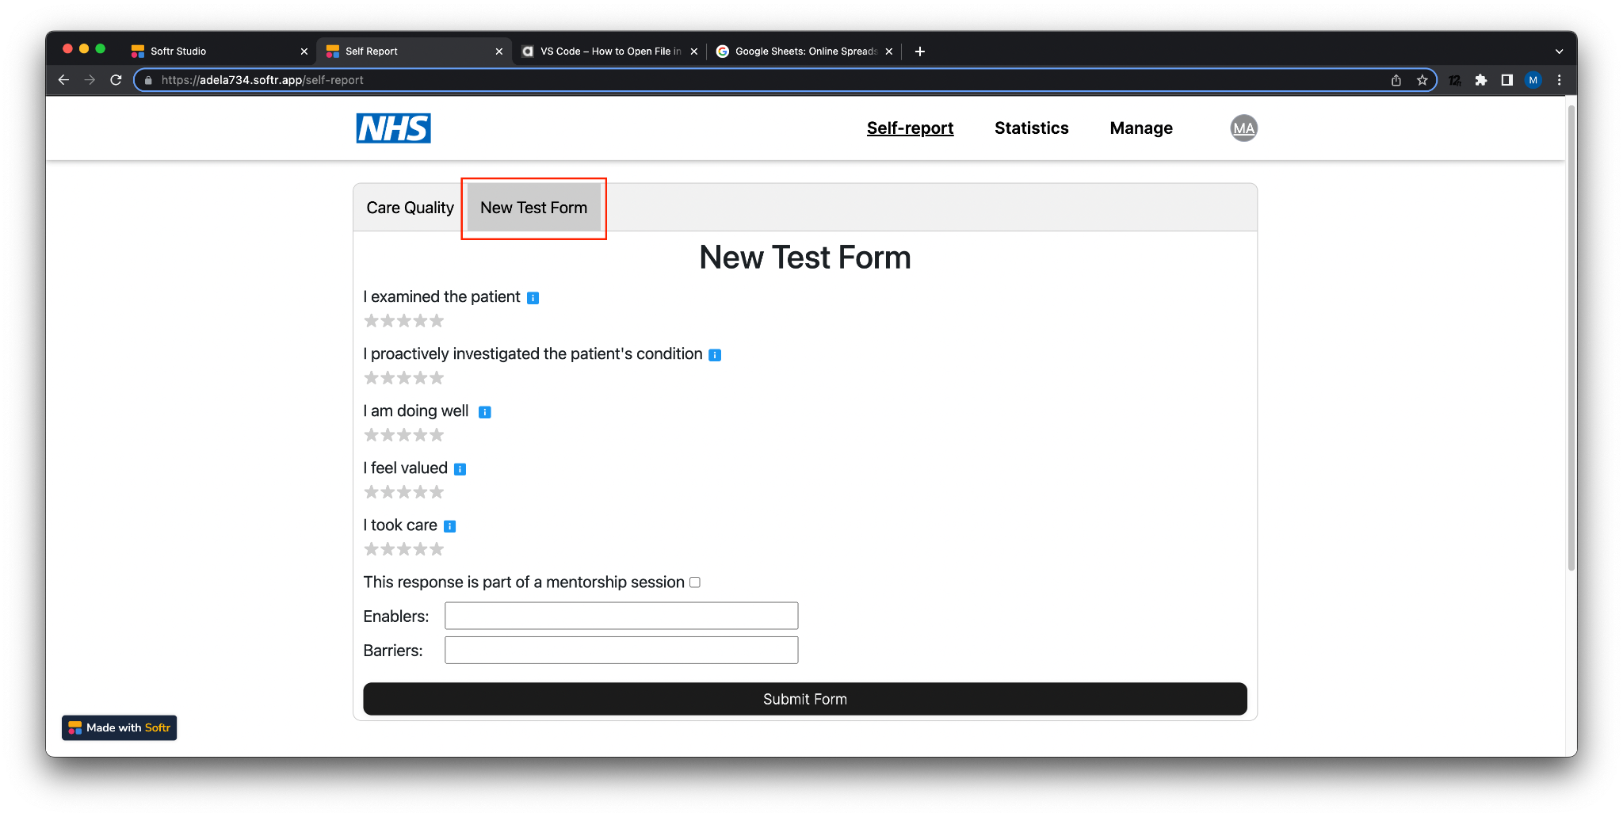
YES/NO

Now fill it in twice, remember to enter Enablers and Barriers and go to the Statistics page.
Under “Your Personal Stats” change the “Choose a form to Visualise” toggle from “Care Quality” to the name of the new form you created. You should see the stats, enablers and barriers for the responses you just completed.
YES/NO
Now go down to “Your team’s stats”, your newly created form should appear here, it should look the same as the personal statistics page as the the responses all come from the same logged in user.
YES/NO

Log in as sbryant (the other user this form is published to) using the following credentials:
- Email: sbryant@example.com
- Password: sbryant123!
Complete a few self assessment submissions for the form you created, you should now see your personal stats page populated with the new entries. Click “Download Chart” and confirm the chart has been downloaded.
YES/NO

Now log back into the system as the user you created (the team manager), go to the “Your team’s stats” page. You should see the combined stats for both your user and sbryant

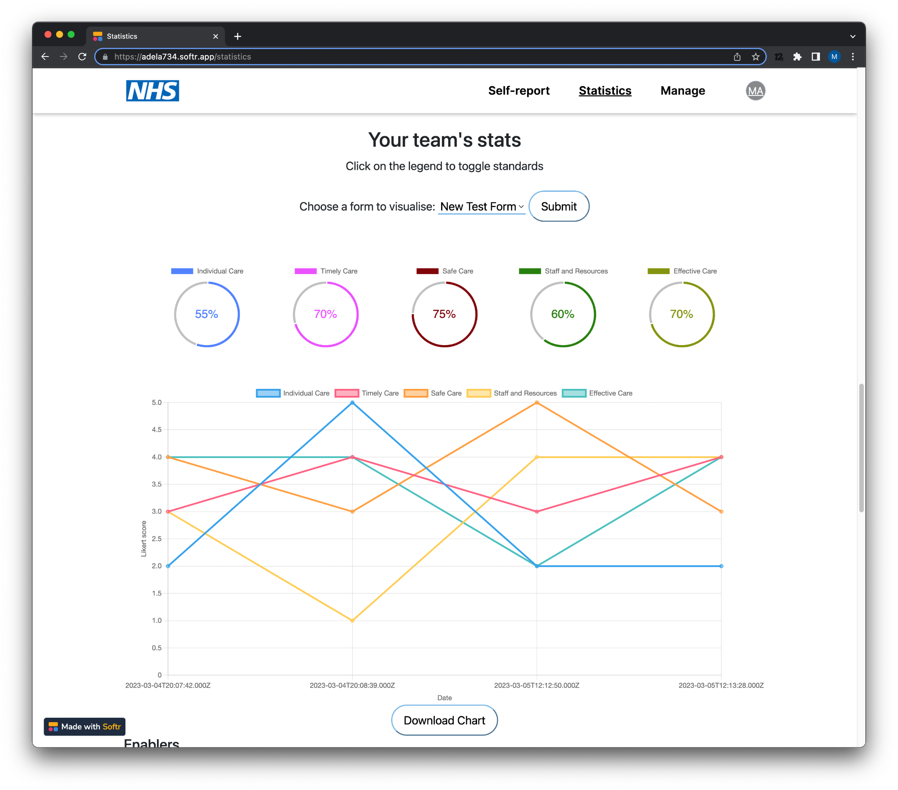
YES/NO

